Lab 01

**Lab Task**

1. Make 2-2 programs of each datatype.

Ans: Integer(int)

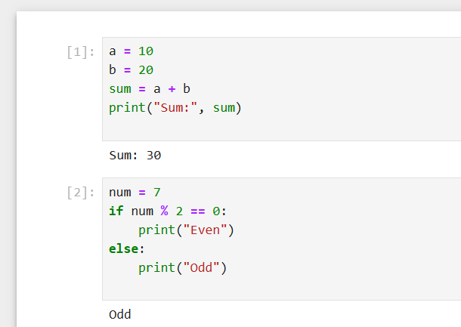

Float(float)

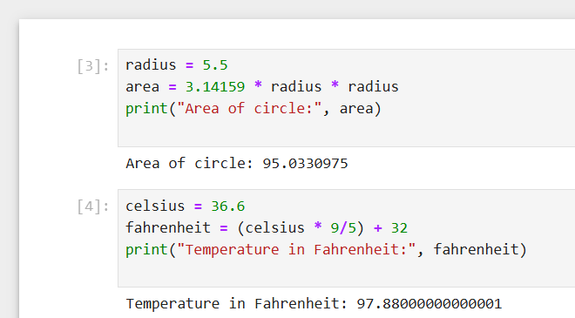

String(str)

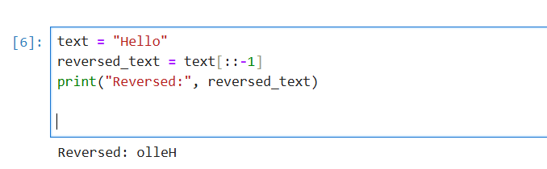

List(list)

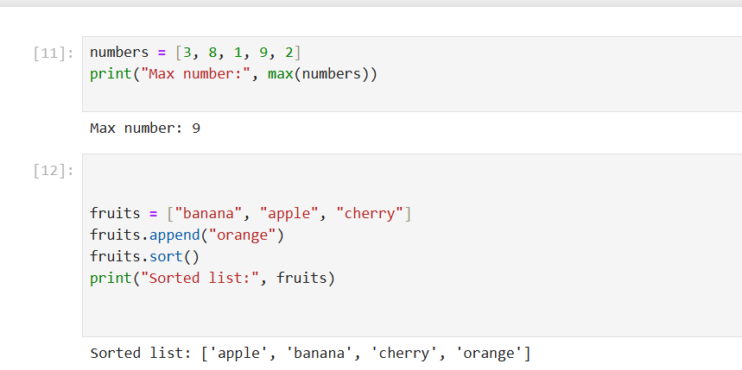

Tuple (tuple)

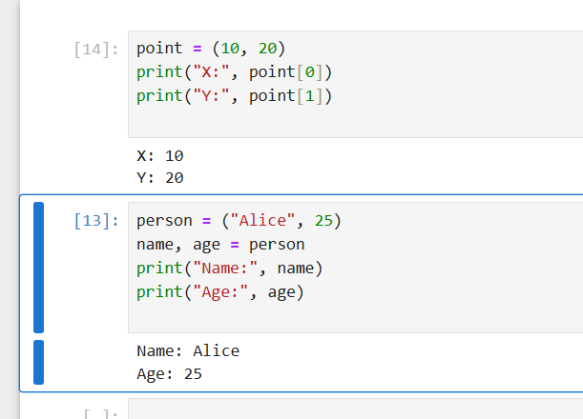

Dictionary (dict)

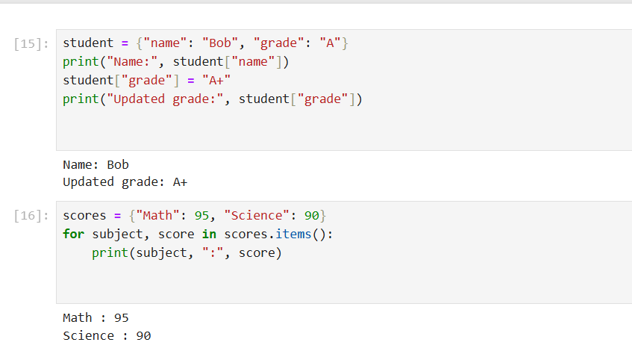

Set (set)

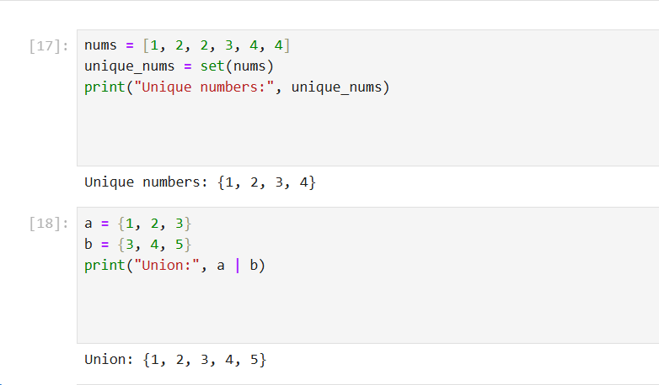

1. Make up to 5 Shape programs using *.

Ans: Right-Angled Triangle

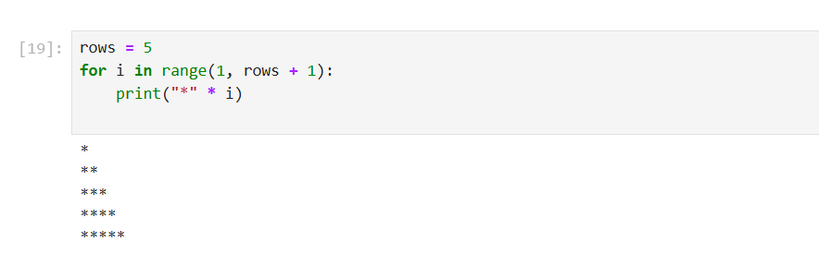

Left-Aligned Triangle

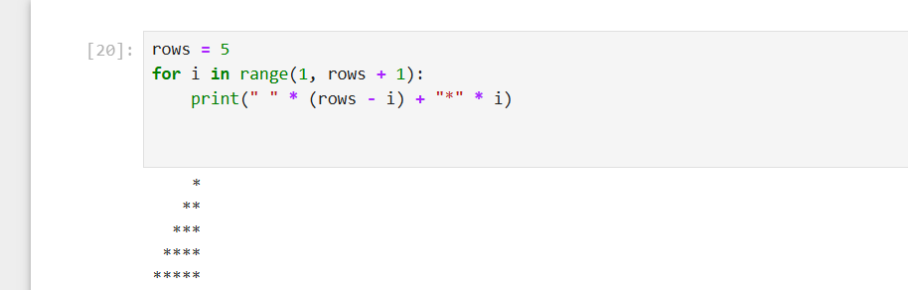

Pyramid

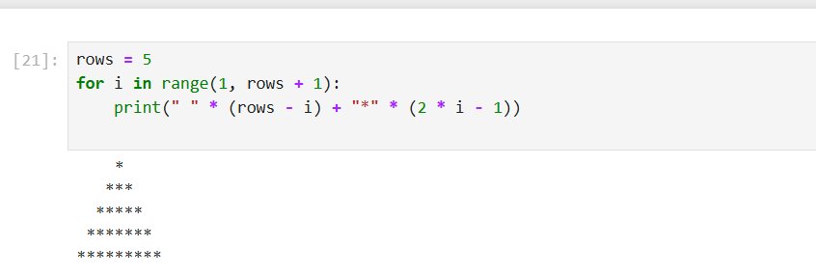

Diamond

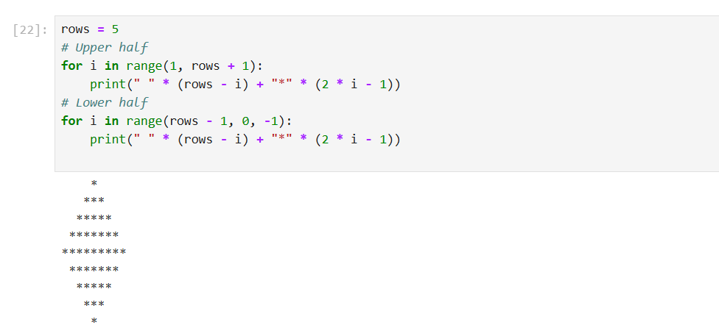

Inverted Triangle

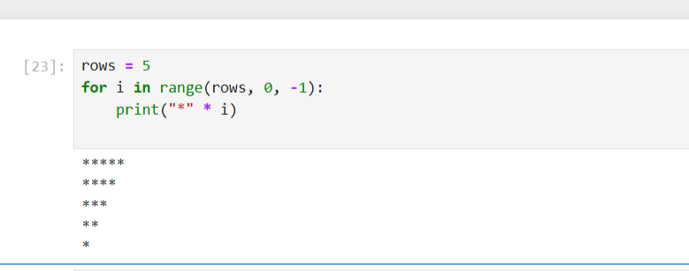

1. Make same shapes you have made in task 2, using * mutiple by number.

Ans: Right-Angled Triangle using * × number

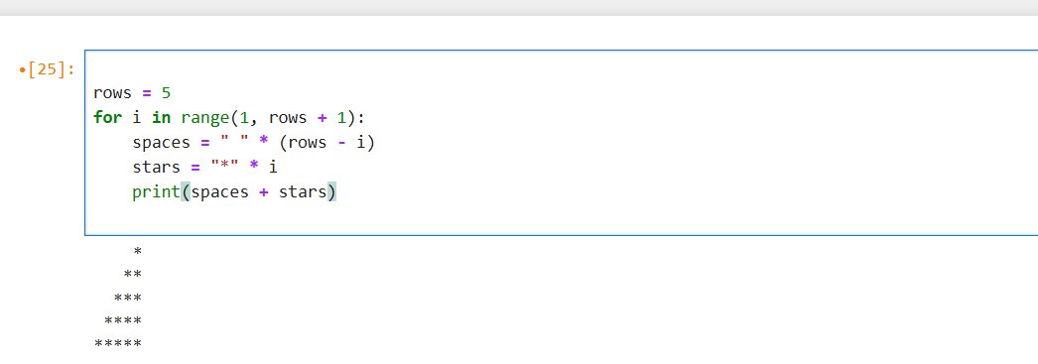

Left-Aligned Triangle using * × number

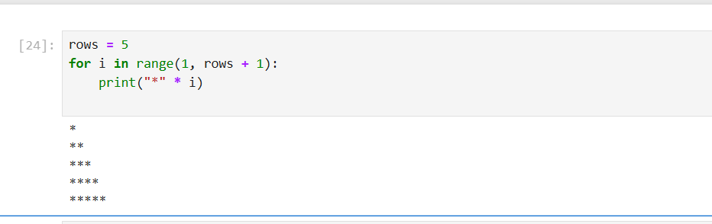

Pyramid using * × (2 * row - 1)

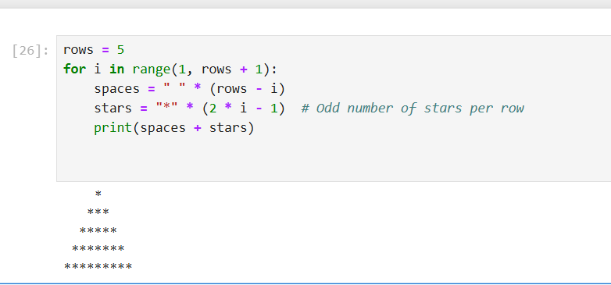

Diamond using * × (2 * row - 1)

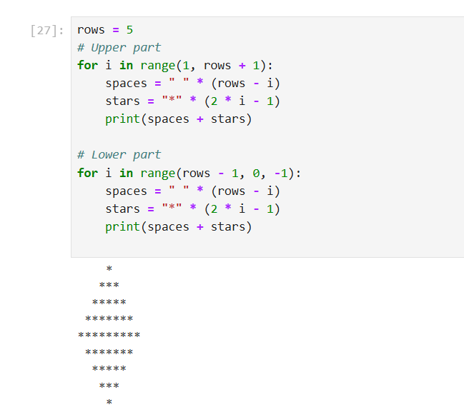

**Python Looping Tasks**

1. **Print numbers from 1 to 10 using a for loop.**

Ans:

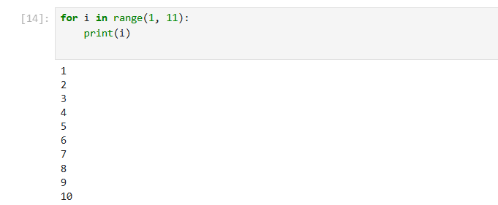

1. **Print all even numbers between 1 and 20 using a while loop.**

Ans:

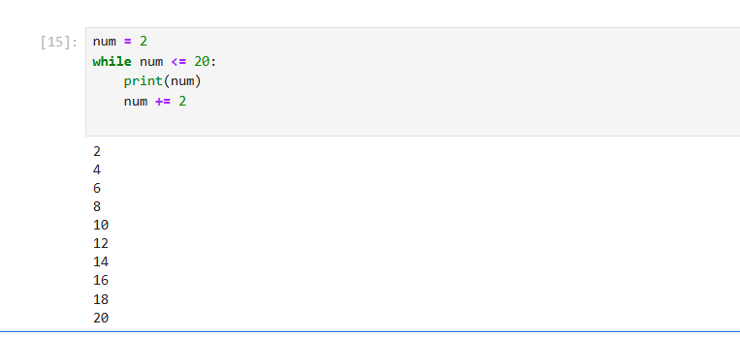

1. **Calculate the sum of numbers from 1 to 100 using a loop.**

Ans:

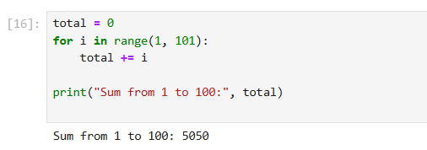

1. **Print the multiplication table of 5 using a loop.**

Ans: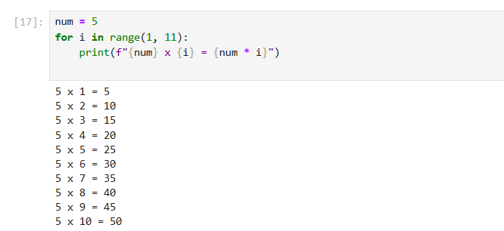

1. **Find the factorial of a given number using a for loop.**

Ans: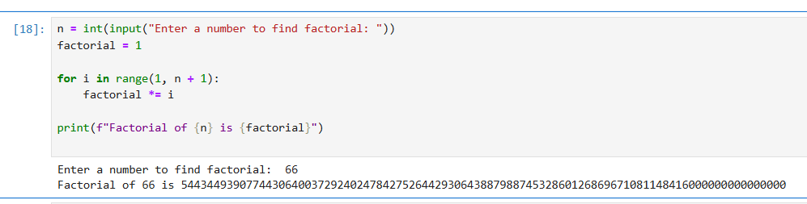

1. **Iterate over a list of fruits and print each item.**

Ans: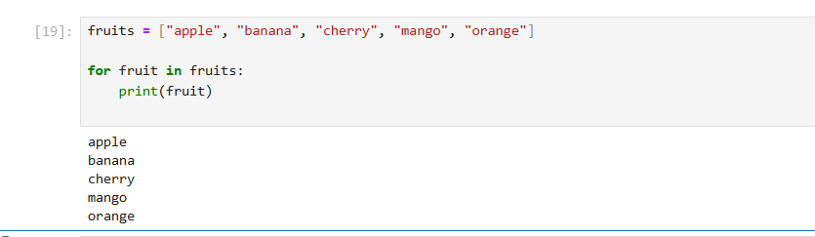

1. **Create a list of numbers and print only the odd numbers using a loop.**

Ans:

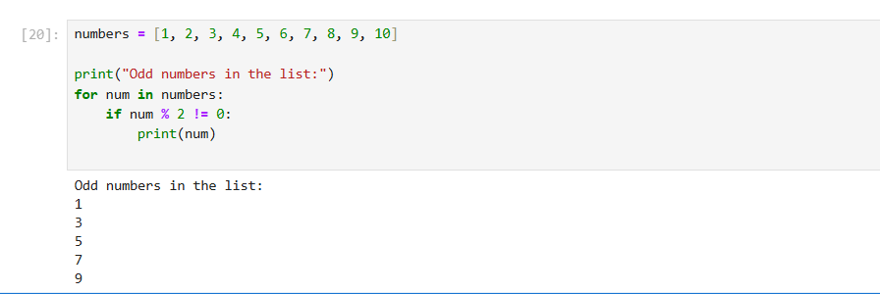

Lab 04

**Lab Tasks**

1. Write a Python program to take two numbers as input and perform all arithmetic operations on them.

Ans:

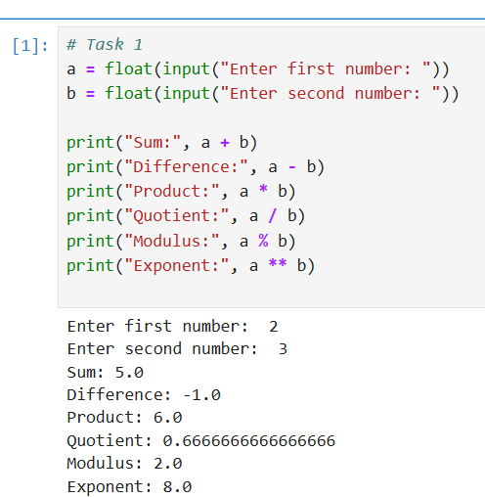

1. Create a function that takes two numbers and returns their sum, difference, product, and quotient.

Ans:

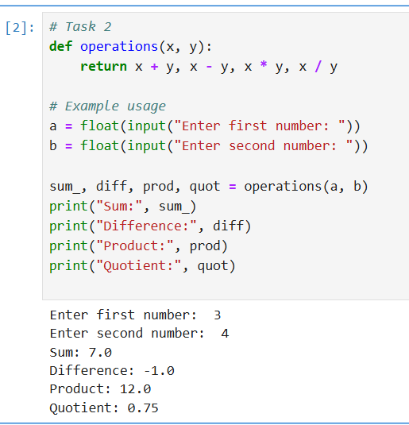

1. Write a Python script to find the remainder when one number is divided by another.

Ans:

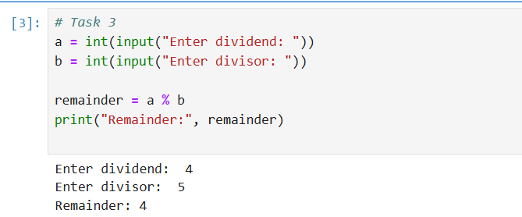

1. Write a program to calculate the area of a circle using the formula: Area = π * r^2.

Ans:

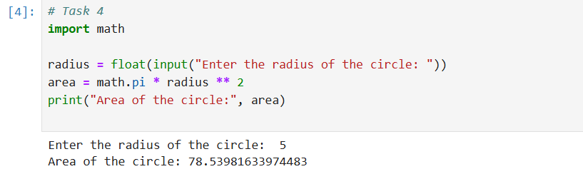

1. Implement a program that takes a number as input and returns its square and cube using exponentiation.

Ans:

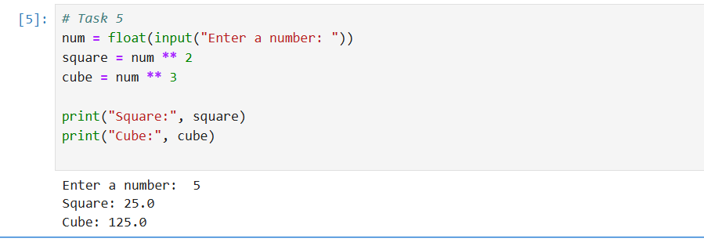

1. Create a simple calculator in Python that allows the user to choose an operation (addition, subtraction, etc.) and inputs two numbers.

Ans:

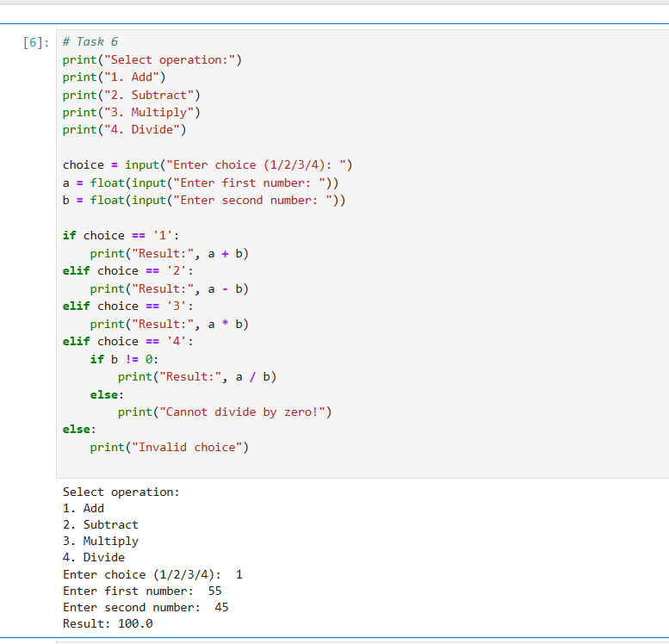

LAB 05

LAB TASKS

1. **Basic Task:** Write a program that checks if a given number is positive, negative, or zero.

**Ans:**

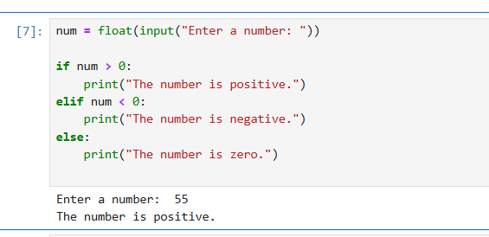

1. **Intermediate Task:** Write a program that takes user input and determines whether it's a even or odd.

**Ans:** 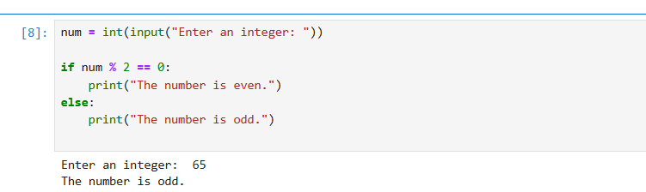

1. **Advanced Task:** Create a program that asks user to print:
   * "Excellent" if marks are above 80
   * "Good" if marks are between 60 and 80
   * "Needs Improvement" if marks are below 60

Ans:

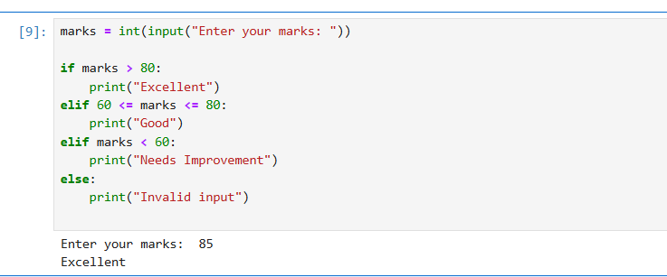

LAB 06

LAB TASKS

1. **Basic Task:** Write a for loop to print the first 10 natural numbers.

**Ans:**

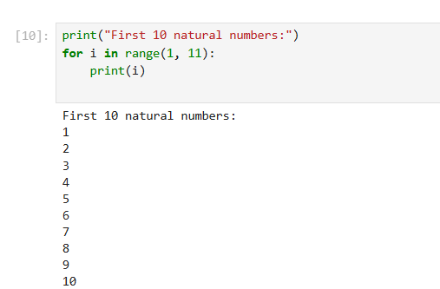

1. **Intermediate Task:** Write a while loop that prints numbers from 10 down to 1.

**Ans:**

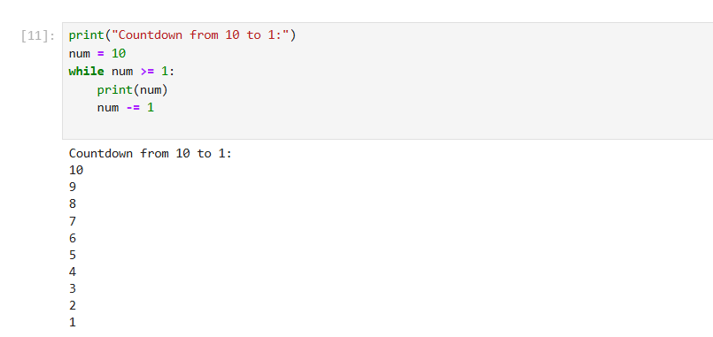

1. **Advanced Task:** Create a program that uses a for loop to iterate over a string and count the number of vowels.

**Ans:**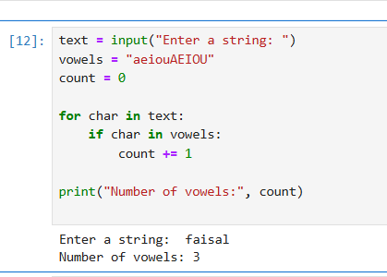

1. **Challenge Task:** Write a program that prints the Fibonacci series up to n terms using a while loop.

**Ans**

**:**